**Updating the Provisional Temporary Permits GIS Layers**

9/5/2013

Rev 20220701 TPS – additional processes for geodatabase update

**Part I: Update Process**

**Part II: Installing necessary tools**

**Part III: Old Update Process? (no longer needed)**

REQUIREMENTS:

**ARCINFO or ARCEDITOR License**

[**OWRBGIS@esri_owrp.sde**](mailto:OWRBGIS@esri_owrp@Arapaho.sde) **SDE connection**

[**OWRBGIS@esri_owrt.sde**](mailto:OWRBGIS@esri_owrt@Arapaho.sde) **SDE connection**

**Quick Start:**

If you have run the PT update before, use the instructions below.

If you have not run the PT update before, skip down to **Part II: Update Setup Section**

**Part I: Update Process**

Open the ArcMap Project **G:\Programs\Water_Rights\z_GIS_App\PTs\PT_Update106.mxd**

Open the ArcToolbox

Add the Toolbox

G:\GIS\ArcGIS\Toolboxes\ **Z_SDE_Layers_Update106**

Run this model **FROM EDIT MODE**, Water Rights > PTs > **1aRemoveOldFilesPTs**

*(right click, click “edit”, “run entire model”)*

*(may get an error that says these do not exist, or WARNING #####: Warning empty output generated.)*

Note: The models only generate points and lands for the past 6 months. Adjustments to avoid duplication of points are made in models 2a and 2b.

From ArcMap:

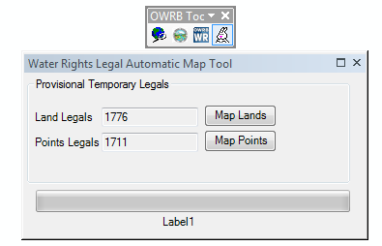Click the “ ” icon to begin the update process.

A dialog box will open and look similar to the image below:

Click the [ **Map Points** ] box to start the processing of

the points layer. (~5 minutes)

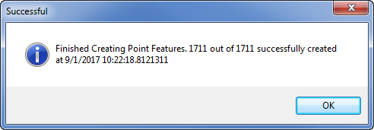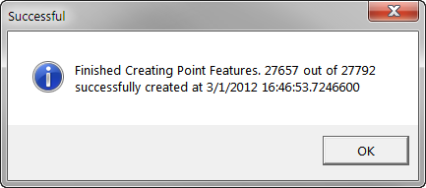

After the points have completed, click the [ **Map Lands** ]

button to process the lands. (~5 minutes)

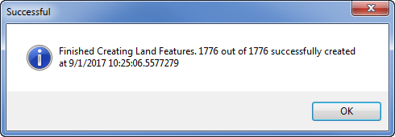

Close the [ **Water Rights Legal Automatic Map Tool** ] dialog box

Turn on both the layers [ **OWRBGIS.WR_PT_Points** ] and [ **OWRBGIS.WR_PT_Lands** ]

Check the features and attribute tables. If everything looks good:

Run the model, Water Rights > PTs > **2a) Update PT Points on Test**  (~12 minutes)

The model will add attribute information and format the attribute table.

It will create 2 new layers [ **WR_PT_Points_All** ] and [ **WR_PT_Points_Active** ]*

*Active – queries the {EXP_DATE} field and selects all records that are >= CURRENT_DATE

Run the model, Water Rights > PTs > **2b) Update PT Lands on Test**  (~7 minutes)

The model will add attribute information and format the attribute table.

It will create 2 new layers [ **WR_PT_Lands_All** ] and [ **WR_PT_Lands_Active** ]*

*Active – queries the {EXP_DATE} field and selects all records that are >= CURRENT_DATE

Run the model Water Rights > PTs> **2cCreatePTLandsTable** (~1 minute)

This model creates a table version of the PT lands that is related to the points feature class for use in the web maps. The lands themselves are not accurate for half divisions, and this is a (hopefully temporary) workaround .

Run the model, Water Rights > PTs > **3) Update PT Layers on Production&CSA**

The model will copy [ **WR_PT_Points_Active** ] and [ WR_PT_Lands_Active ]

to OWRBGIS@esri_owrp.sde (Production) and to owrp_csa.sde

[ **WR_PT_Lands** ] and [ **WR_PT_Points** ].

Add the updated layers from [ **GIS_User** ]

Inspect the results and check the metadata.

Close the ArcMap project and do not save.

**\*\*STOP HERE \*\***

**Update the PT Personal Geodatabase**

**Need ArcInfo (Advanced) License**

Run the following models from **Z_PT_Water_Rights_102**:

**aDeletePTGDB**

This will delete the [ **PTs.mdb** ] on G:\Temp

**bCreatePTGDB**

This will create a new PTs.mdb on G:\Temp

**c1CalcFieldsAndRC**

This will calculate the fields and create relationship classes

**c2CreateIdenticalPointsTable - Modify Start Date**

**Open in Edit mode and change the date** of the Make Feature Layer tool to two years prior to the current date. This tool creates a table requested by Water Rights staff that will assist them in determining whether a single entity is requesting multiple sequential PTs in one area.

**d1 Export Shapefile And Table**

This will export a shapefile of the points and a table for the lands for download from the website.

**d2CreateSummaryTables**

This will create summary tables of the PT and save them to:

\\ARAPAHO\MasterCovs\z_GDBs\z_sum_Tables\

**eDeleteArapahoGDB**

This will delete the gdb \\Arapaho\MasterCovs\z_GDBs as WaterRights_PTs.gdb

**fCopyPTGDBtoArapaho**

This will copy the PTs.gdb to \\Arapaho\MasterCovs\z_GDBs as WaterRights_PTs.gdb

**gUpdateWRMetadataDateforPTs**

This updates PT metadata that will be uploaded to the website and linked to ArcGIS Online metadata files

hZip Files for Download

This zips up files in \\owrbgis\geodat\temp\MasterCovs and exports them to the V drive for website upload

**iExportSHPMetadata**

This export to htm format metadata that will be uploaded to the website and linked to ArcGIS Online metadata files

**PT Update complete.**

Go to: Updating the Oil and Gas Water Rights FGDB

Need to create a script that adds the PT data to the Water_Rights.gdb on a nightly basis.

**Updates in February**The PT PGDB script is set up to create yearly summary tables. These scripts need to be updated for the new year for the February run so that January 20xx PTS are shown in the tables and on the maps. The **dCreateSummaryTables** model needs the following portions updated for the new year (date needs to be changed to reflect last 20 years; e.g., 1996 to 2016)

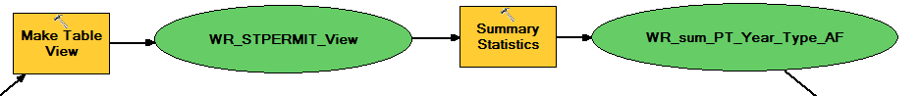

New yearly table needs to be created:

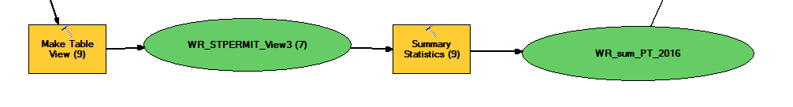

Also be sure that this table is exported to .dbf.

**Part II: Update Setup Section**

**Tool Installation:**

The PT Points and PT Lands GIS layers are created by a VB.net program that reads all of the records from the WR.WR_STPERMIT and WR.WR_STLEGAL tables in the Water Rights database. The legal descriptions contained in the WR_STLEGAL table are automatically mapped based on the layer OWRBGIS.PLSS_Q3.

There is a .dll used to generate the Point and Land locations associated with the PT records.

The .dll is created from the source code located in the vb project: wr_automap.sln

\\THUNDERBIRD\VB_Projects$\WR\Prod\GIS\DLLs\wr_automap.dll

Resources:

|  |  |
| --- | --- |
| errorlog | \\thunderbird\VB_Projects$\WR\PROD\GIS\Logs\automaplog.txt |
| LandsLayer | OWRBGIS.WR_PT_Lands |
| LandsLayerTmp | OWRBGIS.WR_LT_Lands_TMP |
| LandsLog | \\thunderbird\VB_Projects$\WR\PROD\GIS\Logs\PTLandsLog.csv |
| PointsLayer | OWRBGIS.WR_PT_Points |
| PointsLog | \\thunderbird\VB_Projects$\WR\PROD\GIS\Logs\PTPointsLog.csv |
| PTORLT | PT |
| Q3StateGrid | OWRBGIS.PLSS_Q3 |

Using Windows Explorer, navigate to:

G:\GIS\ArcGIS\ArcMap\Admin\Installation\Docs\Arc_10_1\UserProfiles\Custom_DLLs\WR_Automap

Copy the following folder to the user’s PC: G:\GIS\ArcGIS\ArcMap\Admin\Installation\Docs\ArcGIS 10.2\Custom_Tools

From that folder, copy wr_automap.dll , wr_automap.tlb to:

C:\Program Files (x86)\ArcGIS\Utilities\ ( 64bit )

C:\Program Files\ArcGIS\Utilities\ ( 32bit ) – this is the arcgisw7 location

Open ArcCatalog

Navigate to: [OWRBGIS@esri_owrt.sde](mailto:OWRBGIS@esri_owrt@Arapaho.sde) (Test Database)

The following layers are used in the PT layers creation

OWRBGIS.WR_PT_Points

OWRBGIS.WR_PT_Lands

Make sure that there are no records in either one of these layers. This is where the calculated records will be added.

Close ArcCatalog

Open ArcMap

Make sure the “**OWRB Tools**” tool bar is loaded.

Open the Customize Dialog box

Click the Commands tab

Scroll down to [ **Water Rights Application** ]

Click [ **Add from File** ]

Navigate to [ **C:\Program Files (x86)\ArcGIS\Utilities\** ] 64bit or [ **C:\Program Files\ArcGIS\Utilities\** ] 32bit

Select the file: [ **Wr_automap.tlb** ]

Click [ **Open** ]

A rabbit icon with the text “**Water Rights Legal Automatic Map Tool**” should now be in the “Commands” window.

Drag this icon to the “**OWRB Tools**” tool bar.

Close ArcMap.

Register the tools:

For 32-bit, double-click G:\GIS\ArcGIS\ArcMap\Admin\Installation\Docs\ArcGIS 10.2\Custom_Tools\AG102_Register_DLLs_wr_automap.dll_32bit.bat to register the .dll

For 64-bit, double-click G:\GIS\ArcGIS\ArcMap\Admin\Installation\Docs\ArcGIS 10.2\Custom_Tools\AG102_Register_DLLs_wr_automap.dll.bat to register the .dll

**End of tool setup. Go back to Part I.**

*The following remains for posterity only*

**Part III: Old Notes**

**Data Processing:**

Open the ArcMap Project:

**G:\Programs\Water_Rights\z_GIS_App\PTs\PT_Update.mxd**

The following data layers should be in the project:

OWRBGIS.PLSS_Q3

OWRBGIS.WR_PT_Lands

OWRBGIS.WR_PT_Points

OWRBGIS.WR_LT_LANDS_TMP

Open the ArcToolbox

Add the Toolbox

G:\GIS\ArcGIS\Toolboxes\ **Z_SDE_Layers_Update**

Run the model, Water Rights > PTs > **1) Remove Old Features**

This model will:

Remove all of the existing features from [ WR_PT_Lands ] and [ WR_PT_Points ]

Delete the temp feature classes:

[ WR_PT_Lands_TMP_Legal ] , [ WR_PT_Lands_A ] ,

[ WR_PT_Points_TMP_Legal ], [ WR_PT_Points_A ]

Click the [ **Water Rights Legal Automatic Map Tool** ] tool.

Click the button to [ **Map Lands** ]

*Currently this will create a polygon for all lands in the [ **WR_STLEGAL** ] table

The polygons will be added to the [ **OWRBGIS.WR_PT_Lands** ] layer

Click the button to [ **Map Points** ]

*Currently this will create a point for a wells and diversions in the [ **WR_STLEGAL** ] table

The points will be added to the [ **OWRBGIS.WR_PT_Points** ] layer

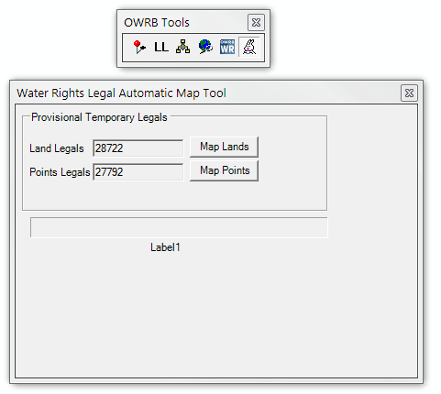

The two layers only contain limited attribute information. They need to be joined to the [ **WR_STLEGAL** ] and [ **WR_STPERMIT** ] tables to add the location and permit information attributes.

Run the model, Water Rights > PTs > **2) Update PT Layers**

This model will:

**Points**

1) Join the [ **WR_STLEGAL** ] table from [ **OWRP** ] and create an new feature class

[ **WR_PT_Points_TMP_Legal** ]

2) Join the [ **WR_STPERMIT** ] table from [ **OWRP** ] and create a new feature class [ **WR_PT_Points_A** ]

This new feature class only contains the Active PT points

3) Copy the point features to [ **OWRP** ] [ **OWRBGIS.WR_PT_Points** ]

This will replace the old features in the layer

4) Update the metadata

**Lands**

5) Join the [ **WR_STLEGAL** ] table from [ **OWRP** ] and create an new feature class

[ **WR_PT_Lands_TMP_Legal** ]

2) Join the [ **WR_STPERMIT** ] table from [ **OWRP** ] and create a new feature class [ **WR_PT_Lands_A** ]

This new feature class only contains the Active PT lands

3) Copy the point features to [ **OWRP** ] [ **OWRBGIS.WR_PT_Lands** ]

This will replace the old features in the layer

4) Update the metadata

NOTE:

Status Code Lookups

NULL – Pending Approval

A – Approved

E – Expired

D – Draft

R – Rejected